SCIENTIFIC CALCULATOR
Course code and section: CSE115 section 4
Project group number: 09
Team members:
1. Nafew Zaman (2534052642)
2. Maksud Ibne Al Kafi (2533867642)
3. M. M. Nur Ibne Hasnat (2533176642)
4. Nafi Monsur (2532380642)

1. Abstract
Scientific calculators are widely used in science and engineering education for accurate mathematical computation. This project implements a menu-driven scientific calculator in C that supports basic arithmetic and common scientific functions such as trigonometry, logarithms, factorials, and quadratic equation solving. Trigonometric inputs are accepted in degrees and converted internally. The system also includes an ANS memory register and file-based history, following structured programming practices with modular design and basic error handling.

3. Introduction
Calculators are fundamental computing systems that demonstrate core programming concepts such as user interaction, numerical processing, and control flow. Scientific calculators extend these capabilities by providing functions frequently required in academic and engineering contexts.
This project focuses on developing a scientific calculator using the C programming language. C is widely used in education due to its support for structured programming and close interaction with system resources. The implementation applies control structures, modular functions, and file handling in a compact and practical application.
To improve usability, the calculator includes an ANS memory register to store the most recent result and a persistent history feature that saves results to a file. These additions make the program more realistic while remaining suitable for introductory coursework.

4. Objectives and Scope
Objectives
- Develop a menu-driven scientific calculator using C.
- Implement basic arithmetic and scientific functions accurately.
- Accept trigonometric inputs in degrees with internal conversion.
- Store the most recent result using an ANS memory register.
- Maintain calculation history using file handling.
- Handle common input errors safely.
Scope
The program is console-based and does not include a graphical interface or expression parsing. Complex numbers are not computed explicitly. The focus is on clarity, correctness, and alignment with course-level expectations.

5. Related Work
Scientific calculators exist in hardware, desktop, and mobile forms, often offering advanced features such as expression parsing and graphical interfaces. While powerful, these systems are less suitable for instructional purposes.
In academic settings, calculator projects are commonly used to teach control flow and modular design. However, features such as persistent history are less frequently implemented. This project extends standard educational implementations by incorporating file-based history and an ANS memory register while relying on the standard C math library for accuracy.

6. System Design
The calculator operates within a continuous interactive loop where users select operations from a menu. The design emphasizes modularity, with separate functions handling computation, validation, memory storage, and history management.

6.1 Modules and Responsibilities
- User Interface: Displays menus and collects input.
- Computation Core: Performs arithmetic and scientific calculations.
- Validation Layer: Ensures valid inputs and safe operation.
- ANS Memory: Stores the most recent result.
- History Manager: Saves, displays, and clears calculation history.

6.2 Architecture Diagram
Figure 1 presents the high-level architecture, illustrating how the user interface routes requests to the computation core and how results are stored in ANS memory and recorded by the history manager.
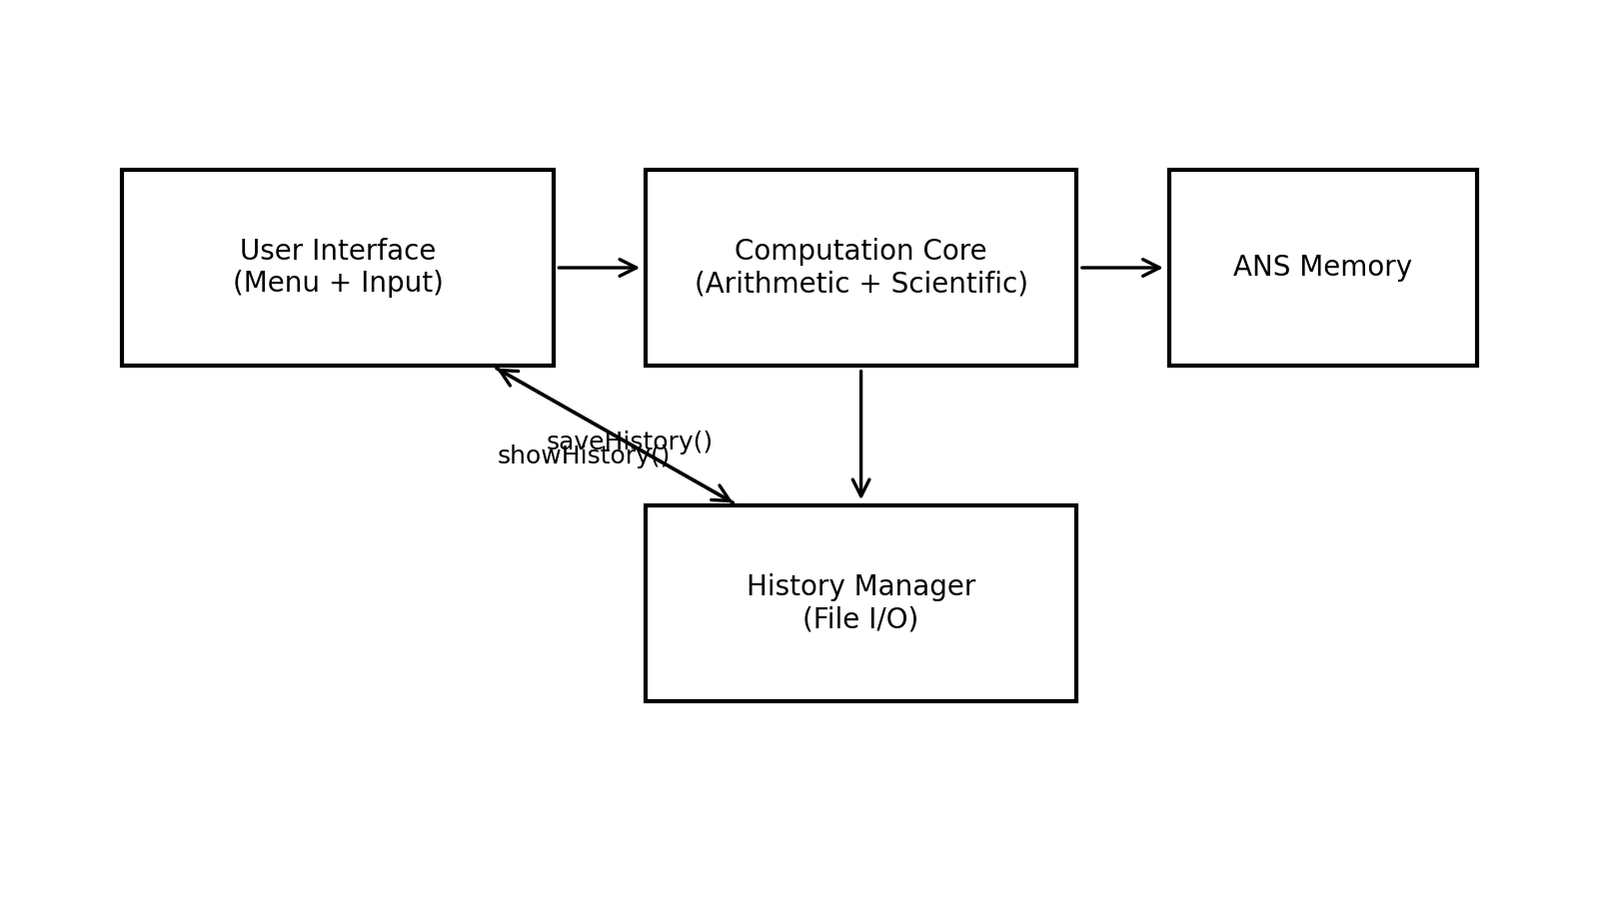
Figure 1. High-level architecture of the scientific calculator.

6.3 Control Flow
Figure 2 summarizes the control flow from user selection through computation, memory update, and history logging. The do–while loop ensures that the menu is shown at least once and continues until the exit option is selected.
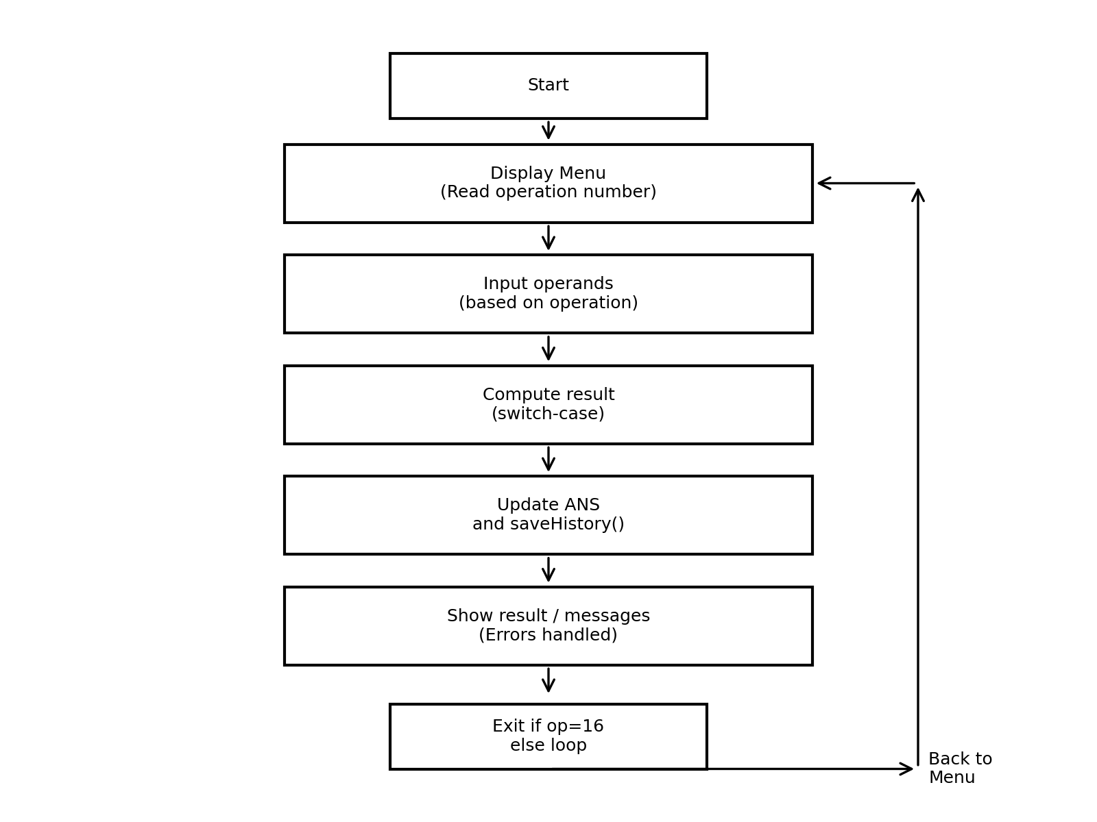
Figure 2. Flowchart of the main loop and operation execution.

7. Implementation Details

7.1 Data Types and Output Formatting
The program primarily uses the double data type to support fractional values, while int is used for menu selections and factorial input. Numerical results are displayed with four decimal places for consistency, except factorial results, which are shown as integers.

7.2 Arithmetic Operations
Addition and subtraction operate on two inputs, while multiplication supports multiple operands using an iterative loop. Division includes validation to prevent division by zero. Invalid operations display an error message and do not update ANS or history.

7.3 Scientific Operations
Scientific functions rely on the C math library. Square root requires a non-negative input, and the natural logarithm requires a positive input. Exponentiation is handled using the standard power function. Domain validation prevents undefined results.

7.4 Trigonometry in Degrees
Trigonometric functions internally convert degree input to radians before computation. This conversion is applied consistently for sine, cosine, and tangent. Extremely large tangent values at undefined angles are treated as expected numerical behavior.

7.5 Factorial
Factorial is implemented iteratively for non-negative integers. Negative input is rejected. Overflow for large values is possible and documented as a limitation.

7.6 Quadratic Equation Solver
The solver evaluates the discriminant to determine the nature of the roots. Real roots are computed when possible, repeated roots are handled correctly, and complex roots are reported without calculation. If the leading coefficient is zero, the equation is rejected as non-quadratic.

7.7 ANS Memory
ANS is implemented as a global variable storing the most recent valid result. Failed or invalid operations do not update this value, ensuring result integrity.

7.8 History Logging
Calculation history is stored in a text file using append mode to preserve results across executions. History can be viewed or cleared through file read and overwrite operations. The format is simple and suitable for coursework requirements.

7.9 Portability
The program is compatible with standard C compilers and requires linking with the math library where applicable. File handling uses standard library functions to ensure portability. If file access is restricted, the calculator remains functional without history persistence.

8. Algorithms and Pseudocode

8.1 Main Program Algorithm
The main loop can be summarized by the following pseudocode:
- Initialize ANS = 0
- Repeat
- Display menu options
- Read operation selection op
- Switch on op
- Case arithmetic/scientific operation: read operands; validate; compute; display; update ANS; save history
- Case show ANS: display ANS
- Case show history: read and display history file
- Case clear history: overwrite history file
- Case exit: terminate loop
- Default: report invalid selection
- Until op is exit

8.2 Multi-Operand Multiplication
The multiplication feature supports N operands using iterative accumulation:
- Read N
- result ← 1
- For i = 1 to N:
- Read x
- result ← result × x
- Display result

8.3 Time and Space Complexity
Most operations run in constant time, O(1), because they call a fixed number of library routines. Multi-operand multiplication is O(N) in the number of operands. Factorial is O(n) in the input integer n. Space usage is O(1) for computation; history storage grows linearly with the number of recorded computations.

9. Testing and Results
Testing focused on correctness, domain validation, persistence behavior, and user interaction. Outputs were compared against known mathematical values and standard calculator expectations.

9.1 Functional Coverage
Table 1 summarizes supported functions, expected inputs, and validation conditions.
Operation | Input | Validation / Notes
Addition, Subtraction | Two doubles | Always defined
Multiplication | N doubles | Iterative; result initialized to 1
Division | Two doubles | Divisor ≠ 0
Square Root | One double | Input ≥ 0
Power | Two doubles | Uses pow()
Sin, Cos, Tan | Angle in degrees | Converted to radians
Natural Log | One double | Input > 0
Factorial | One int | Input ≥ 0; overflow possible for large n
Quadratic Solver | a,b,c as doubles | a ≠ 0; complex roots reported

9.2 Representative Correctness Tests
Table 2 lists representative tests used to confirm correctness.
Test ID | Operation / Input | Expected | Observed
T1 | 12.5 + 7.25 | 19.75 | 19.75
T2 | 10 / 0 | Error | Error message shown
T3 | √81 | 9 | 9.0000
T4 | ln(1) | 0 | 0.0000
T5 | sin(30°) | 0.5 | 0.5000
T6 | cos(60°) | 0.5 | 0.5000
T7 | 5! | 120 | 120
T8 | Quadratic: a=1,b=−3,c=2 | 1 and 2 | 1.0000 and 2.0000
T9 | Quadratic: a=1,b=2,c=5 | Complex roots | Complex roots

9.3 Boundary and Error-Case Tests
Table 3 highlights boundary and invalid-input cases used to validate error handling.
Case | Input | Expected Handling
Division by zero | a / 0 | Print error; do not update ANS; do not save history
Negative square root | √(−4) | Print error; do not update ANS; do not save history
Non-positive logarithm | ln(0), ln(−2) | Print error; do not update ANS; do not save history
Negative factorial | (−3)! | Print error; do not update ANS; do not save history
Non-quadratic a=0 | a=0,b=2,c=1 | Print 'Not quadratic'; return
History file missing | history.txt not present | Show message 'No history found'

9.4 Sample Program Output
Figure 3 provides a sample interaction demonstrating trigonometric evaluation.
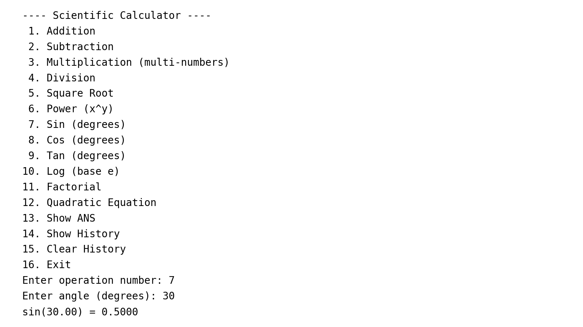
Figure 3. Example console interaction for sin(30°).
Figure 4 shows a sample view of the persisted history file as displayed by the program.
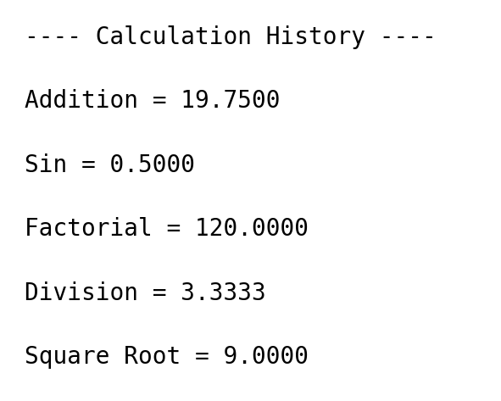
Figure 4. Example of calculation history display (read from history.txt).

10. Discussion

10.1 Design Rationale
A switch–case menu provides a clear and efficient structure for a fixed set of operations. Modular functions improve readability, reduce redundancy, and simplify maintenance.
duplication and improving readability.

10.2 Numerical Accuracy and Floating-Point Considerations
Scientific computations typically involve floating-point arithmetic, which is subject to rounding and representation limits. Using double provides sufficient precision for most coursework calculations. Nevertheless, certain values (for example, tan near 90 degrees) may yield very large magnitude outputs due to the mathematical properties of the function and finite-precision arithmetic. Similarly, factorial grows rapidly and may overflow beyond moderate values of n. These behaviors are expected in numeric computing and are documented as limitations rather than treated as defects.

10.3 Usability and Persistence
ANS memory and persistent history improve usability by allowing result reuse and review. These features enhance the learning experience without increasing system complexity.

11. Limitations
- Complex roots in the quadratic solver are detected but not computed and displayed in complex form.
- Input handling is scanf-based; malformed inputs may require restarting the program if the input stream becomes inconsistent.
- History records operation labels and results only; operands and full expressions are not stored, limiting traceability.
- Large factorial inputs and extreme trigonometric inputs may overflow or yield very large results due to numeric limits.
- The application is console-based and does not support graphical interaction or expression parsing (e.g., evaluating '2+3*4' as a single input).

12. Future Work
- Support complex roots in quadratic equations.
- Store full expressions in history.
- Improve input handling robustness.
- Add more scientific functions.
- Separate computation logic for reuse in GUI or web interfaces.
- Introduce automated testing.

13. Conclusion
This project demonstrates the implementation of a structured, menu-driven scientific calculator in C. It supports essential arithmetic and scientific functions, degree-based trigonometry, ANS memory, and persistent history. The design emphasizes clarity, correctness, and educational relevance, providing a strong base for future expansion.

14. References
[1] B. W. Kernighan and D. M. Ritchie, The C Programming Language, 2nd ed., Prentice Hall, 1988.
[2] ISO/IEC 9899:2018, Information technology — Programming languages — C.
[3] ISO C standard library documentation for <stdio.h> and <math.h> (fopen, fprintf, fgets, sqrt, pow, sin, cos, tan, log).
[4] cplusplus.com, “C library reference,” documentation pages for stdio and math functions.
[5] OpenAI, ChatGPT (AI-assisted writing and editing), accessed 2025-12-13.

15. Appendix

15.1 Build and Run Instructions
Example build command (GCC):
gcc calculator.c -o calculator -lm
Example run command:
./calculator
On many systems the math library must be linked explicitly using −lm.

15.2 User Guide
A concise usage guide is provided below:
- Launch the executable; the menu will be displayed.
- Enter the operation number corresponding to the desired function.
- Provide the requested operands when prompted (angles are entered in degrees for trigonometry).
- Read the printed result. If an error message is printed, correct the input and retry.
- Use option 13 to display ANS (the last valid result).
- Use option 14 to display prior results stored in history.txt.
- Use option 15 to clear stored history if needed.
- Use option 16 to exit the program.

15.3 History File Behavior
The history file is created automatically when the first successful computation is recorded. If the file does not exist and the user selects history display, the program reports that no history was found. Clearing history overwrites the file with an empty file, effectively deleting all stored entries while keeping the filename consistent for subsequent writes.

15.4 Disclosure of External Resources
Standard references for C and the C standard library were used to confirm function behavior and required build flags. AI assistance was used for drafting and language refinement; final technical content and project decisions were verified against the source code and standard documentation. All external resources consulted are listed in the References section.

